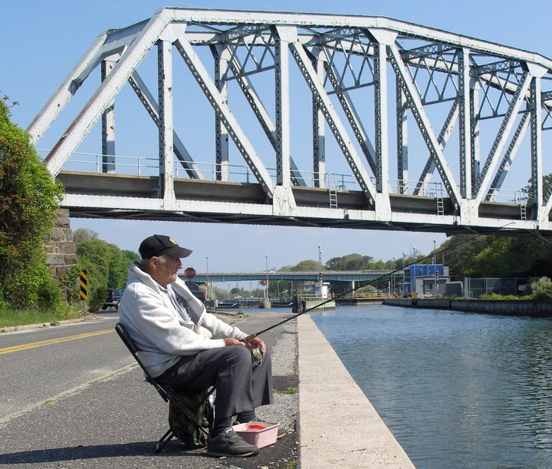**2025 Hampton Bays Fire Department Fluke Tournament Registration/Liability Waiver**

In consideration of this application being accepted, I/we the below captain & crew, the captain’s signature intending to be legally bound for myself/crew, my/our heirs, executors and administrators, waive and release any and all rights and claims for damages I/we may have against Hampton Bays Fire Department officials, employees, representatives, successors or assigns or anyone acting on their behalf. Such claims for damages to include but not to be limited to liability for death, personal injury or property damage of any kind or nature whatsoever arising out of or in the course of my/our participation in the Hampton Bays Fire Department Fluke Tournament. Furthermore, if applicable I/we agree to reimburse the Hampton Bays Fire Department Fluke Tournament for any and all attorney’s fees, court costs, and/or other expenses incurred by I/we as a result of any action, claims or suits arising out I/we participation with the Hampton Bays Fire Department Fluke Tournament. In further consideration of this application being accepted, I/we recognize that unexpected dangers may arise during the course of the Hampton Bays Fire Department Fluke Tournament and that my/our activities are such that they will not be subject to close monitoring during the duration of the event. I/we certify that I/we am/are physically fit to participate in this tournament and that my/our vessel and gear are in safe operational condition. By signing this waiver and release, I/we certify that we and our vessel are covered by a valid insurance policy covering injury to ourselves, others and property damage caused by me/us during the course of this event and related activities. This release and waiver extends to all claims of any kind or nature whatsoever, foreseen or unforeseen, known or unknown.

**0-5 is free; 6-15 is juniors; 16+ Adult (ages for Categories)**

**BBQ tickets: 0-5 free; 6-20 is $20, 21+ is $30**

**Boat Name: _______________________________ Juniors Pricing-$20 Pre-Registration**

**-$25 Day of**

**Capt. Name**: _______________________________ **Adult Pricing-$60 Pre-Registration**

**-$70 Day of**

**Address:** _______________________________

___________________,________,___________

**Phone:** (____) _______-___________

**Crew Member (print name):** _________________________Junior/Adult

**Crew Member:** **(print name):** _________________________ Junior/Adult

**Crew Member: (print name):** _________________________ Junior/Adult

**Crew Member: (print name):** _________________________ Junior/Adult

**Crew Member:** **(print name):** __________________________ Junior/Adult

**Captains Signature:** X_________________________________________

(Print Cpt. Name) ______________________

***The captain’s signature validates crew on board to the said agreement above. It will be the captain’s

Responsibility to review this waiver with his/her crew prior to the event if a crewmembers name is not on

A waiver he/she will not be a participant in the 2025 Hampton Bays Fire Department Fluke Tournament.